# Love One Another Word Search | Sermons4KidsThe Catholic Toolbox: Gospel for the Mass: 5/9/21- John 15:9-17Love One Another**Love One Another Crossword**

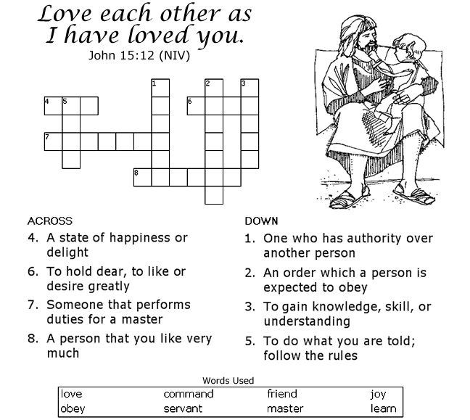

Bible Memory Verse

"My command is this: Love each other as I have loved you."  
John 15:12 (NIV)

